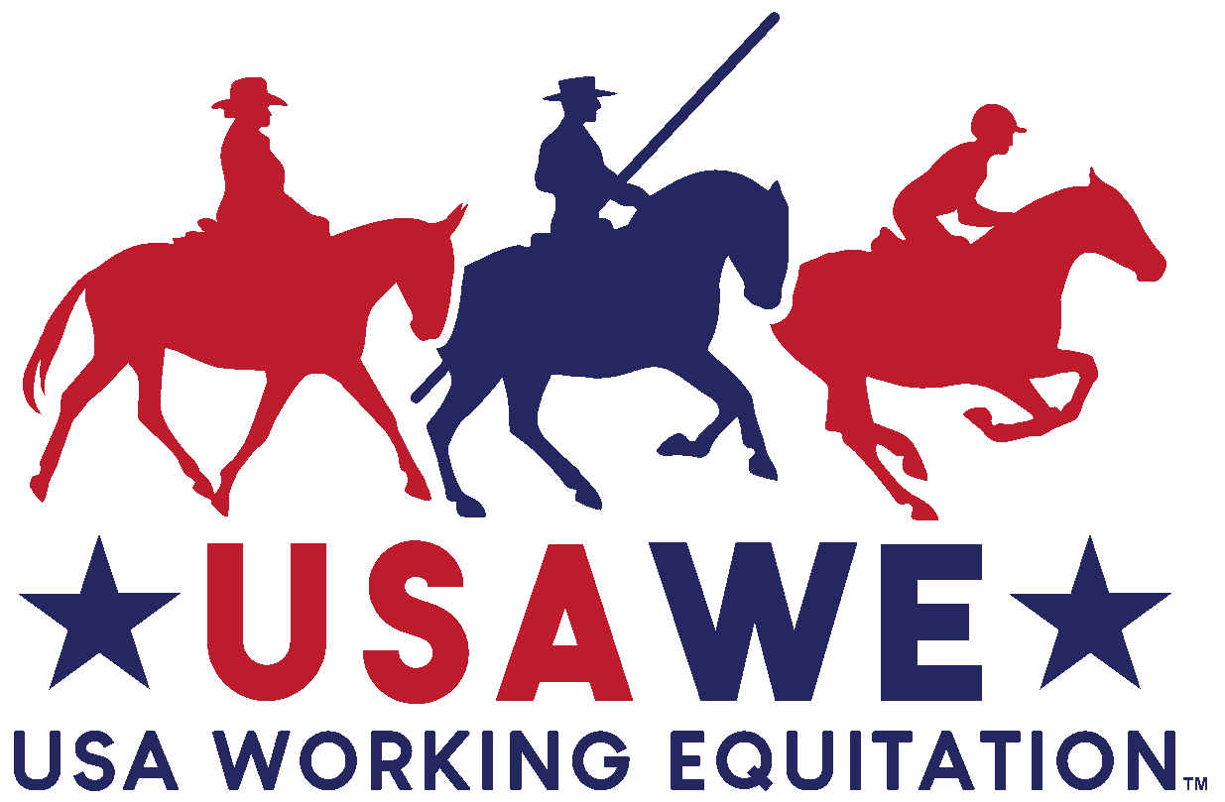 |  |  | USA WORKING EQUITATION (USAWE)  SHOW ENTRY FORM  GELINAS FARM #2  SHOW DATE: Sunday, June 19, 2022  SHOW LICENSE No. __22-068_________________ |  |  |  |  |  |  |  | ENTRY NO:
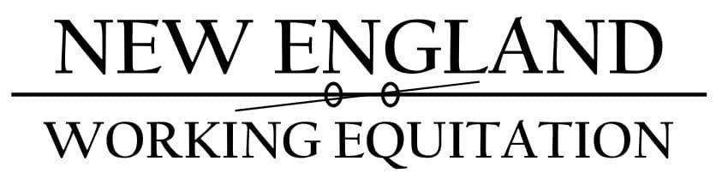 |  |  | SHOW SECRETARY (name, address, phone, email)  Deb Quillinan  4 Sullivan Rd.  Lake George, NY 12845  debquill@gmail.com 518-260-8292 |  |  |  |  |  |  |  | All information must be completed.  One entry form per horse.  Please submit entry to Show Secretary by: June 1, 2022______________
RIDER NAME |  |  |  |  | PHONE |  |  |  |  | FEE TYPE |  | AMOUNT
ADDRESS |  |  |  |  |  |  |  |  |  | L1 –  INTRO |  | $150
EMAIL |  |  |  |  |  |  |  |  |  | L2 –  NOVICE A |  | $200
MEMBERSHIP No. |  |  |  |  | DATE OF BIRTH (Youth) |  |  |  |  | L3 –  NOVICE B |  | $200
DISPENSATION? No _____ Yes _____  If yes, attach Dispensation Certificate. |  |  |  |  | SHOWING IN: |  |  |  |  | L4 –  INTERMEDIATE A |  | $200
 |  |  |  |  | OPEN |  | AMATEUR | YOUTH
HORSE NAME |  |  |  |  | BREED |  |  |  |  | L5 –  INTERMEDIATE B |  | $200
HORSE RECORDING No. |  |  |  |  | DATE OF COGGINS |  |  |  |  | L6 –  ADVANCED |  | $200
AGE | SEX |  |  | IF MARE, BREEDING DATE (if applicable) |  |  |  |  |  | L7 –  MASTERS |  | $200
OWNER NAME |  |  |  |  | PHONE |  |  |  |  | CATTLE TRIAL (L2-L7)  L1 not eligible
ADDRESS |  |  |  |  |  |  |  |  |  | OFFICE FEE |  | $25- NEWE members exempt for 1 show
EMAIL |  |  |  |  |  |  |  |  |  | STALL FEE |  | $25/night
PAYMENT FORM |  | CHECK No. |  |  |  |  |  |  |  | LATE FEE |  | $75
ARE YOU A 2022 MEMBER OF NEWE? |  |  |  |  |  |  |  |  |  | NON USAWE MEMBER FEE |  | $20
 |  |  |  |  |  |  |  |  |  | TOTAL FEES

This document waives important legal rights. Read it carefully before signing.

RELEASE:
I understand that this is a high-risk sport and I am participating at my own risk. I hereby assume this risk and further do hereby release and hold harmless the organizer (Licensee), organizing committee, competition management, judges and officials; USA Working Equitation (USAWE) its officers, agents, employees and volunteers; the host of this event or competition; and the owners of any property on which the event or competition is being held, from all liability for negligence resulting in accidents, damage, injury, or illness to myself and to my property, including the horse or horses that I will compete at this event or competition.

ENTRY AGREEMENT:
By entering a USAWE-licensed competition and signing this entry form as the Owner, Rider, or Parent/Guardian, I agree that I am subject to and agree to be bound by the Bylaws of USAWE applicable to the USAWE-licensed competition, the U.S. Rules for Working Equitation (“Rules”), and the requirements of the competition as stated in the Prize List. I will accept as final the decision of the Protests Committee or Appeals Committee on any question arising under the Rules and agree to release and hold harmless the competition, USAWE, their officials, officers, directors, employee, agents, personnel, volunteers, and USAWE affiliates for any action taken under the Rules. I represent that I am eligible to enter and/or participate under the Rules and every horse I am entering is eligible as entered. I also agree that as a condition of and in consideration of acceptance of entry, USAWE and/or competition management may use or assign photographs, videos, audios, cablecasts, or other likenesses of me and my horse taken during the course of the competition for the promotion, coverage, or benefit of the competition, sport, or USAWE. Those likenesses shall not be used to advertise a product and they may not be used in such a way as to jeopardize amateur status. I hereby expressly and irrevocably waive and release any rights in connection with such use, including any claim to compensation, invasion of privacy, right of publicity, or to misappropriation.

In consideration for my participation in this Competition, I AGREE to the following:
- I AGREE that USAWE and the Competition as used herein include the Licensee and competition management, as well as all of their officials, officers, directors, employees, agents, personnel, volunteers, and USAWE affiliates.
- I AGREE that I choose to participate voluntarily in the Competition with my horse as a rider, owner, or parent/guardian of a junior exhibitor. I am fully aware and acknowledge that horse sports and the Competition involve inherent dangerous risks of accident, loss, and serious bodily injury including broken bones, head injuries, trauma, pain, suffering, or death (“Harm”).
- I AGREE to hold harmless and release USAWE and the Competition from all claims for money damages or otherwise for any Harm to me or my horse and for any Harm of any nature caused by me or my horse to others, even if the Harm arises or results, directly or indirectly, from the negligence of USAWE or the Competition.
- I AGREE to expressly assume all risks of Harm to me or my horse, including Harm resulting from the negligence of USAWE or the Competition.
- I AGREE to indemnify USAWE and the Competition and to hold them harmless with respect to claims for Harm to me or my horse, and for claims made by others for any Harm caused by me or my horse while at the Competition I have read the Rules about protective equipment (section 1.9.1.k) and I understand that I am entitled to wear protective equipment without penalty. I acknowledge that USAWE strongly encourages me to do so while warning that no protective equipment can guard against all injuries. I represent that I have the requisite training, coaching, and abilities to safely compete in this competition. If I am a parent or guardian of a junior exhibitor, I consent to the child’s participation, AGREE to all of the above provisions, and AGREE to assume all of the obligations of this Release on the child’s behalf. I understand and AGREE that all competitors under the age of 18 must wear an ASTM/SEI-approved safety helmet.
- I AGREE that if I am injured at this Competition, the medical personnel treating my injuries may provide information on my injury and treatment to USAWE and competition management.

BY SIGNING BELOW, I AGREE to be bound by all applicable USAWE rules, all terms and provisions of this entry form, and all terms and provisions of the Prize List. If I am signing and submitting this Agreement electronically, I acknowledge that my electronic signature shall have the same validity, force, and effect as if I affixed my signature by my own hand.

OWNER/AGENT SIGNATURE  (Mandatory) | RIDER SIGNATURE  (Mandatory) | PARENT/GUARDIAN SIGNATURE  (For Riders under 18) (Mandatory)
PRINT NAME | PRINT NAME | PRINT NAME
RIDER EMERGENCY CONTACT INFORMATION (Name /Relationship) |  | PHONE

